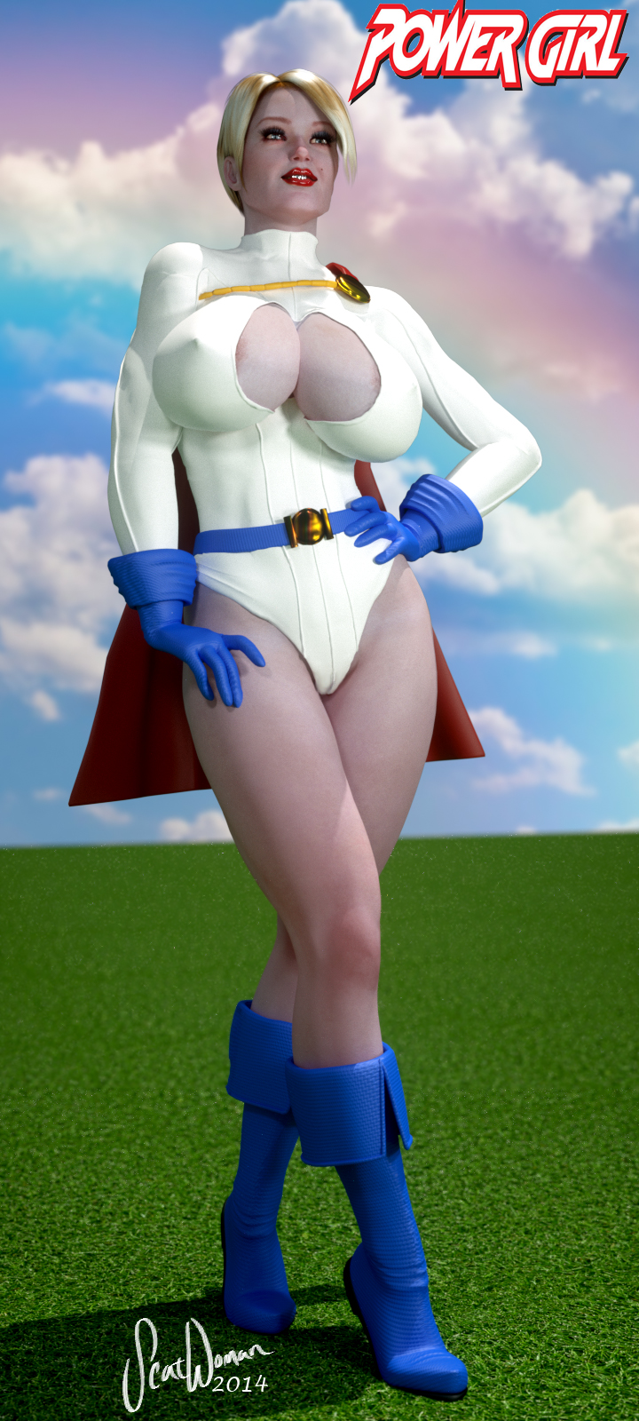
She-Hulk vs. Power Girl
Story and Art by Scatwoman@aol.com
Chapter 1: “Savaged By She-Hulk!”

It was a dark and stormy night…

Power Girl flew high above Metropolis. When she was a safe distance, she pulled her costume’s crotch to the side and pulled the rather phallic 14-inch Mega Rod from her pussy. Big Barda had let her borrow it, though she didn’t know exactly what Power Girl’s intentions were for it.

Power Girl had propositioned Mr. Terrific and Cyborg to modify it for her in exchange for a threesome (which she would have done for free – she’d never really had a need for men, but there was something about black guys that excited her). Not that Power Girl was any slouch, herself – she had a genius level intellect and was very tech savvy, having run her own tech company, Starrware Labs, as her alter-ego Karen Starr. But this required some very specific level of technical experience that very few on Earth possessed, including those two fine gentlemen. So she got what she wanted and had a good time to boot.

Now she hovered over her adopted home city here in the “Earth Prime” dimension (as the natives call it) and activated the pussy-slickened Mega Rod, modified to open a Boom Tube to Power Girl’s home dimension – Earth 2.

Having left Supergirl in the Kent barn with a stable full or horny stallions (see the series “Supergirl’s Cumming of Age”), Power Girl had set off to make her way back to her own Earth and bring back some more playmates for the little blonde teen Superbitch.

However, just as she activated the Mega Rod, a massive lightning bolt shot from an ominous black cloud and struck the device, electrocuting Power Girl in the process! A Boom Tube opened below Power Girl and she fell into it along with the smoking, sparking Mega Rod.

…..

Pedestrians walked hurriedly along the busy metropolitan street, trying to avoid contact on this hot and sunny late summer afternoon.

But one broke the city’s unwritten rule of “never speak to or make eye contact with strangers” when he heard a sound reminiscent of an incoming mortar and looked up into the sky.

“Look!” he yelled, “it’s a bird!”

Another pedestrian looked up, startled, “No!” she screamed, “it’s a plane!”

“No!” came the voice of a young kid stepping forward from the crowd and pointing at the object rapidly plummeting to Earth, “it’s S-“

SMASH! The figure plowed into the corner of a building, taking out parts of the first three floors and blowing out the walls. A fire hydrant broke and started spraying water high into the air. Smoke rose from a crater in the sidewalk.

A shaky blue hand reached up out of the hole and Power Girl, shaken but unharmed, clambered out of the hole.

“It’s a chick!” the kid yelled, “and she’s got HUYOOOOOGE BOOBIES!!!”

Power Girl realized everyone was staring at her and looked down. One of her tits had popped out from her boob window.

“Ugh!” the kid’s mother harrumphed and covered the boy’s eyes. But he managed to worm his way around her fingers so he could keep ogling Power Girl’s exposed breast.

“Okay, okay,” Power Girl sighed as she tried her best to shove it back in, “nothing to see here, move along.” It wasn’t easy getting those puppies back on the leash once they’d been set free.

Soon enough, most of the bystanders went about their business. But she got many lascivious leers and disapproving sneers from passers-by.

“What’s the matter?” Power Girl muttered, “never seen a superhero before?”

Power Girl looked around. Something didn’t seem right. This didn’t look like any part of Metropolis she remembered.

“Hmm… too shitty to be Metropolis,” she mused, “but not nearly shitty enough to be Gotham City… where the hell did I land?”

She saw a newspaper dispenser and walked over to it. Looking left and right to make sure nobody saw, she popped open the dispenser without paying. Looking up, she saw a little old lady shaking her head at her.

“Official superhero business,” Power Girl assured her.

“Get a job, you stripper!” the woman yelled back, shaking her umbrella in Power Girl’s direction.

“What the fuck…?” Power Girl shook her head and checked out the front page, looking for a clue as to what city she’d ended up in.

Immediately, she knew something was very, VERY wrong.

The headline read “President Kennedy Opens New Electric Car GM Plant In Detroit”. And below that was a picture of a young-looking Ted Kennedy standing in front of the new plant.

Brow furrowed in concern, she scanned the front page for more clues. The title of the paper was The New York Times and the date… the date was August 22, 1977.

“Oh shit,” Power Girl groaned as she looked around at the thoroughly unfamiliar New York City, “Not again…”

This wasn’t the first time she’d been thrown into a strange alternate dimension. She’d never even known such things existed until she was hurled from her own Earth-2 to “Earth Prime” where she’d been living the past several years. And now she found herself stranded in another, even less familiar alternate…. Wait! NOT stranded! The Mega Rod, maybe it could take her back! Where was it…?

She spun around to head back to the crater and ran head-first into a face-full of big, green tits.

“And what the hell are you supposed to be?” came the voice that towered above the tits.

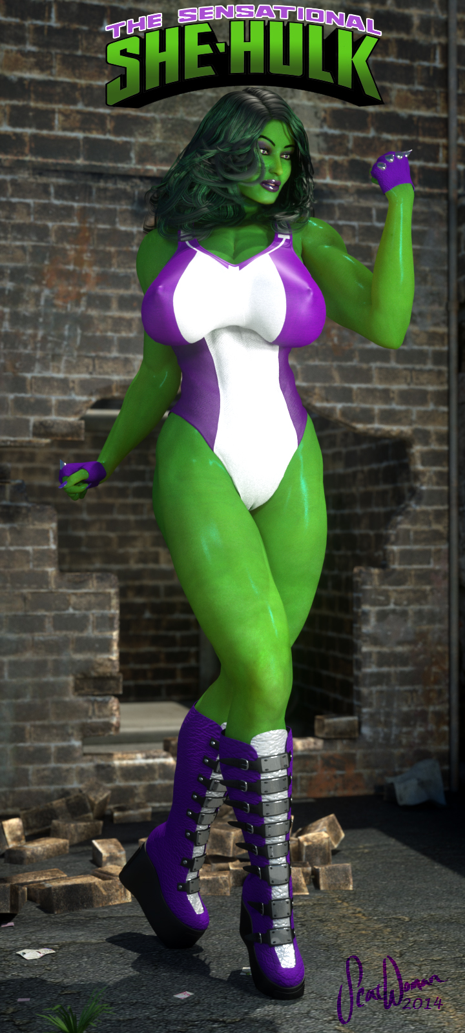
Power Girl took a half step back and looked up at the jade giantess before her. She was busty and voluptuous, muscular, and easily 7 feet tall. Karen was no shorty herself - easily 6'3", but this green giant made her look petite in comparison.

“Who the fuck are YOU?” Power Girl blurted. She’d never seen any hero or villain like this in either dimension she was familiar with.

“Jennifer Walters, attorney at law,” said the green woman confidently, “Most call me She-Hulk.”

“Great. A lawyer,” Power Girl muttered, “I hate lawyers.”

“Real original,” She-Hulk smiled sarcastically, “You gonna give me your name, or should I just call you Supertits?”

“It’s Power Girl!” Karen growled hostilely, poking a finger in She-Hulk’s big, pillowy tits, “She-BULK!”

“GIRL?!” She-Hulk sneered, “You're awfully developed for a *girl*,” she retorted, poking her own finger in Power Girl’s overflowing breast.

“Hey! It's my brand!” Power Girl protested, “I can't change it now, I’ve got name recognition!”

“I should introduce you to Luca,” She-Hulk offered, thinking of how her own black and proud Power Woman would react to some big-titted blonde bimbo running around pretending to be her sidekick, “I'm sure she'd be happy to show you her idea of Power!”

“Well, great chat, but I gotta go,” Power Girl pushed She-Hulk aside with a casual ease that surprised the green giantess, “tell you what, though, Jolly Green Joke: if I need an ambulance chased, I’ll give you a call.”

Power Girl looked in the crater and her eyes lit up as she saw the Mega Rod lying inside. She jumped down and grabbed it, then floated back up out of the crater.

“Whoa now!” She-Hulk, starting to get annoyed, reached out and grabbed Power Girl by the arm. Now it was the blonde’s turn to be surprised by the strength of the other, “you can't just destroy public property and fly away!”

“WATCH me,” Power Girl snapped and wrenched herself free from the Gammazon’s powerful grip.

But She-Hulk recovered quickly. She reached out and grabbed Power Girl’s fluttering cape and hauled her back down as hard as she could, smashing her into the ground with the force of a minor Earthquake.

“You’re grounded, bitch!” She-Hulk growled.

She Hulk looked down and noticed the golden metal rod Power Girl had retrieved was lying on the ground at her feet. She picked it up and shook it, taunting the powerful blonde.

“What’s this?” she grinned, “your boyfriend?”

To her surprise, Power Girl arose easily, looking little more than annoyed, “Give. It. Back.” She growled menacingly.

She-Hulk leaned forward and growled just as menacingly, “MAKE me.”

“That does it,” Power Girl declared, brushing concrete chips off her shoulder, “time for a lesson in Kryptonian manners.”

…..

The super-brawl shook the entire city with its intensity and destruction. Power Girl was a whirl of white and red and blue as she used her speed advantage to pummel the green giantess. But She-Hulk managed to get in some powerful blows of her own; each one hit Power Girl harder than she’d been hit in a long, long time.

It seemed like things were going in the Kryptonian’s favor when she got the tiring Gammazon in a headlock.

“Give it up, green genes!” Power Girl grunted, “You’ve got no chance! You’ve obviously never fought a Kryptonian before!”

“No…” She-Hulk choked as she tried to free herself from Power Girl’s grip of steel, “but I’ve fought plenty of bottle-dyed big-titted blonde bimbos with even bigger egos before!”

Then She-Hulk reached up and grabbed Power Girl’s costume by the boob window fabric and yanked as hard as she could while simultaneously shoving the busty blonde with all her body’s leverage.

Power Girl went flying back into the façade of an abandoned old apartment building, cracking it and falling to the sidewalk.

As she shook off her dizziness from the impact, she noticed people standing around her, taking pictures with their cell phones.

Then she looked over at She-Hulk and saw her drop a large scrap of torn white fabric to the street and grind it into the blacktop with her large metal heel.

Power Girl looked down and saw the entire chest of her costume had been torn off, exposing her huge, pendulous breasts for all to see!

“Do you feel a draft?” She-Hulk taunted her.

Infuriated, Power Girl rose to her feet, leaned forward and unleashed a wide, powerful blast of heat vision right her jade ridiculer, “RAAAAGGGHHHH!!!!!”

She-Hulk, completely unprepared, was hit with the full power of the Kryptonian’s unfettered heat blast. She tried to turn away, to shield herself from it, but her entire body was fried by the incredible searing heat.

Power Girl blasted She-Hulk with everything she had, much longer than she would have needed to just incapacitate her. When she finally stopped, she realized through the fog of rage that had overcome her that she might just have killed the annoying green giant!

But as she smoke cleared, she was shocked to see She-Hulk was still standing. And unscathed.

Except that her entire bodysuit had been incinerated. She-Hulk stood before her, now, completely nude and exposed. Her own huge green tits now hung free and her bare ass faced Power Girl.

“HAH!” Power Girl laughed loudly, “Who’s feeling the draft n-“

She stopped mid-snark as She-Hulk turned around and Power Girl caught sight of the impossibly-large, veiny green Hulk prick dangling between the green giantess’ powerfully muscled thighs!

“What the fuh…??” Power Girl was speechless.

[EX.1230.1.A.0X98.1 TRANSMISSION INTERCEPT: 1A-77/Zeta. POA: Luna. SENDER: Unknown]

I am The Watcher. It is my solemn duty to observe and record all that transpires on the planet Earth. Across all dimensions, all realities, I am witness to the staggering array of possibilities borne by the enormous potential of this unique planet.

Perhaps on your Earth, the story of Jennifer Walters was different. Perhaps her story was simpler, her childhood happier. But that is not the story of this Jennifer Walters. I submit to you:

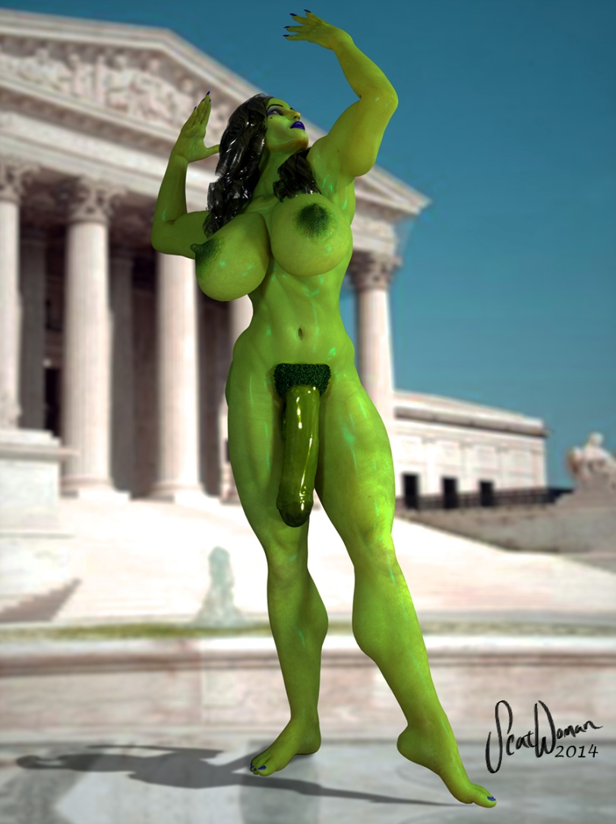
“What If… She-Hulk Was A She-Male?”

The year is 1977. This is Earth-69. However, this Earth, while behind your own by 37 years, is much like your own 1997, or even 2007. In the last decade on Earth-69, the greatest minds of the world united to make the world a better place. Tony Stark, Reed Richards, T'Challa along with Bruce Banner, Heather Douglas and two young lab techs named Henrietta McCoy and Peter Parker formed The Intelligensia - a think tank geared toward improving life through technology. As a result, Earth-69’s 1977 has computers, a nascent Internet, cell phones and electric cars (developed as a response to the oil shortages of the early ‘70's). As a result of the decline in the oil economy, there is poverty in the Middle East, though also relative peace and stability. In 1976 Ted Kennedy was elected President after the disgraceful resignation of Richard Nixon left the country deeply scarred and cynical.

The superheroine known as She-Hulk had an unusual beginning, even for a superhero. She was born with ambiguous genitalia: no vaginal opening, an enlarged clitoris and puffy labia majora. Or perhaps *he* was born with a micropenis and undescended testicles. Doctors were unclear which was the case. The doctors flipped a coin and checked the box marked “male”. The parents named their new “son” Walter… Walter Jennings.

Walter was raised as a male, but inside he always felt female. When puberty hit, his testes dropped and his penis grew some (but was still small). However, she/he also grew breasts, feminine hips and other secondary feminine sex traits. She was a third-sex, an intergendered man/woman hybrid. What came to be known as a she-male in popular parlance.

“Walter” told his parents he wanted to be a woman and they were appalled and less than accepting. Out of heartbreak, disappointment and anger, they disowned Walter. He ran away from home and from that moment on lived as a woman - changing her name to “Jennifer Walters”.

Undeterred by her bizarre background, she hid her secret and worked hard to pay for the best education she could get. Hurt by her parents’ rejection, she decided to get a job making enough money that she would never need to rely on anyone again. She went to the best law school in the country and became a high-powered, successful corporate lawyer.

But her seemingly charmed new life took a major U-turn when Jennifer got in a terrible car accident and nearly died. The hospital staff discovered her transgenderism and her secret was revealed to the only family that showed up to visit her: her cousin Bruce Banner. Jennifer had lost a lot of blood and had a very rare blood type. As it happened, Bruce was a match. He gave her a transfusion and she not only lived, but healed very quickly.

But the near death experience and the exposure of her secret made her rethink her career. After getting encouragement from her cousin to be proud of who she was, she became an advocate and pro-bono lawyer for transgender victims of violence and prejudice. She won every case and helped push forward transgender rights, including the right to marry.

Jennifer eventually discovered that more and more humans (and mutants) were being born like her – a side-effect of the Earth passing through the tail of a rogue comet a couple of decades earlier (at least, according to the prevailing theory among geneticists). Now fully 25% of the population of Earth-69 were being born as the new “third sex”, the “intersex” or “transgendered”. In America, they were called she-males. In Japan, futanari. In India they were called Hijira. Of course, many countries were much less accepting of this change and her kind were systematically persecuted, abused, disenfranchised and even slaughtered. Jennifer made it her personal mission to help her kind around the world, using both her legal expertise and super powers.

One night, after winning a case against a man who had attacked and killed a transgender woman and sending him away for life, Jennifer was attacked by a bunch of bigots on the way to her car. Provoked by the attack, she transformed for the first time – growing into the 7-foot tall jade powerhouse now known as She-Hulk. Bursting from her clothes and revealing her greatly-enlarged, fully erect Hulk Cock, the assailants now hurled insults at her and tried to beat her to death. Enraged, she lost all control and went savage - pummeling each man to the ground.

Jennifer found the angrier she got the stronger she got and the more she lost control. And the angrier she got, the bigger and harder her giant green cock got! And the bigger her cock got, the hornier she got! After subduing her assailants, she raped every one of them in the ass and mouth, putting them in their place. Afterwards, a couple of them actually confessed to enjoying the experience and begged her for her number, but instead she sent them to a transgender brothel she had defended.

In the years since, she became the superheroine known as She-Hulk. Nowadays when she Hulks out, she is able to maintain her control. But she still gets stronger the angrier she gets and her cock still grows bigger, thicker, longer and harder and she gets hornier and more aggressive. Often she gets angry enough that the urge to rape becomes uncontrollable. This has earned her some rather devoted masochists/size-queen bottoms as repeat offenders and arch-enemies.

She-Hulk is one of the founding members of “The Transvengers”, a special team of Avengers comprised entirely of transgender superheroes. At Jennifer’s urging, Tony Stark put the team together in order to raise public awareness of Transgenders and show them as positive role models.

The Transvengers founding roster are all transgenders:
- She-Hulk (Jennifer Walters)
- Black Power (Luca Cage)
- Giant Lady (Cassie Lang)
- Iron Maiden (Pepper Potts - Tony Stark's assistant and, many assume, she-male lover)
- Valkyrie (porn star Seka imbued with the power - and hammer… and cock - of Thor!)
- Miss America (Steve Rogers – the only male-born member. Now Stephanie Rogers, he was turned into a cross-dressing sissy slut by Luca Cage).

Together, The Transvengers fight injustice around the world and try to defend the defenseless and avenge the downtrodden of all races, sexes and cultures.

[EX.1971.0.B.0XH2.7 TRANSMISSION END: 6C-F9/Omega.]

Power Girl was transfixed by the giant cock as She-Hulk strutted toward the stunned blonde Kryptonian. It swung pendulously, as She-Hulk confidently closed the distance between them.

Power Girl felt out of breath as she stared at the swaying cock. Why was she breathing hard? This fight hadn’t been that much harder than any other she’s been in. And it hadn’t even been going that long. Was it the heat vision blast? Why was she feeling so tired suddenly?

“Yeah, that’s right, Power Pussy,” She-Hulk sneered, “take it ALL in. You like it? It gets bigger and harder the angrier I get.”

Power Girl watched in awe as the giant green cock grew and stiffened and rose up to point right at her. She felt weak, exhausted. But she hadn’t been hit *that* hard…

“And the bigger it gets, the HORNIER I get…” She-Hulk growled as she kept getting nearer.

Power Girl couldn’t take her eyes off the incessantly enlarging prodigious prick. It must have been 18 inches long and 8 around already! And it just kept growing!

And with each step She-Hulk took as green giantess closed in on her, the weakness in Power Girl’s knees got more intense. Her knees began to wobble and she had to lean against the brick wall behind her to stay upright. What was wrong with her?

“And you know what, blondie?” She-Hulk asked rhetorically, “I think you just pissed me off more than anyone ever has before!”

Power Girl looked up from the incredible green schlong just in time to take a full-power right hook that sent her smashing through the building clear out the other side and into a filthy back alley.

Lying on the ground, she tried to get up, but she felt weaker and weaker. What was going on? She’d never tired this quickly during a fight before. What was causing this? Something about this dimension… sapping her power? Was the sun the wrong color? No, she thought as she looked up at it, still yellow… then what…

It felt to Power Girl like being drained of her powers by Kryptonite, but there was none around – she didn’t even know if this reality HAD kryptonite! But then what…

Power Girl felt a little bit of strength returning to her… until She-Hulk stepped through the hole in the wall. Suddenly Power Girl felt drained again. Was it *her*? Was the great big green bitch somehow draining her energy?

She-Hulk stepped on Power Girl’s head, pushing her face in a pile of loose bricks and smushing her huge exposed breasts into the dirty alley’s ground.

“Well,” She-Hulk sniffed in self-satisfaction, “I guess Kryptonians aren’t all that tough, after all!”

Then Power Girl realized the truth, to horrifying to accept. Somehow the statuesque green bitch was giving on Kryptonite radiation! Power Girl was so used to being immune to Earth Prime’s kryptonite that she’d forgotten about that vulnerability. On Earth-2, kryptonite had a very different radioactive frequency than kryptonite of Earth Prime. But in this dimension, this green woman was giving off radiation identical to Earth-2 green kryptonite, Power Girl’s only weakness!

“You…” Power Girl gasped, trying to take a breath while her lungs were compressed by her enormous, flattened tits, “… radiation…”

“Hmm?” She-Hulk wasn’t really paying attention to Power Girl, “oh, yeah. Gamma radiation. Cousin Bruce discovered it and it turned him into the original Hulk. All of us Hulks give it off, though in safe enough doses. But I guess it turns Kryptonians into super-pussies, doesn’t it?”

Power Girl groaned. By sheer coincidence, she had the incredible bad luck to get accidentally hurled into the one reality where this great green bitch happened to give off the exact frequency of radiation that sapped her of her strength and powers.

As a result, Power Girl was completely helpless when She-Hulk’s raging hormones took over, the urge to make use of her gamma-powered erection overwhelming her. She-Hulk grabbed Power Girl’s costume by the crotch and tore the bottoms clean off.

Within seconds, She-Hulk had Power Girl completely pinned to the ground, arms behind her back and the jade giantess was plunging her massive green cock into Power Girl’s up-turned asshole!

Power Girl groaned at the feeling of fullness. She’d NEVER had such an enormous cock inside her – especially not in her ass! She-Hulk had hocked up a large loogie and spit on Power Girl’s puckered pink as a make-do lube, but the incredible green cock was just so fucking huge Power Girl felt every excruciating inch as the jade giantess relentlessly drove herself into the pinned blonde’s anal depths until all 24 inches were buried in the Kryptonian’s bowels!

When She-Hulk bottomed out in Power Girl’s butt – the instant her pubes touched Karen Starr’s obscenely stretched anus, the helpless Kryptonian came uncontrollably – thrashing and screaming and flailing like a possessed bitch.

Power Girl had always been on top, even with the men she'd been with – they’d always known she was at least as strong as them. There was a *reason* she chose the name “Power Girl” – she has to be the one with the power. Even when she was getting fucked, she was the one in control. She had NEVER been dominated like this before. NEVER been taken so completely, so unequivocally. Her ass BELONGED to this jolly green Gammazon and her monstrous jade junk.

But her ordeal hadn’t really even begun yet. She inhaled deeply and audibly as She-Hulk withdrew all but her 5-inch head from Power Girl’s anus. Karen’s shit smeared the length of the enormous green monster cock, but neither woman seemed to mind. Power Girl thought she’d completely emptied her bowels down Supergirl’s throat back in the Fortress that morning, but She-Hulk’s cock had obviously reached so deep inside her that she dislodged yet another large deposit.

She didn’t have time to ponder that thought, however, as She-Hulk then SLAMMED her cock all the way back in, making Power Girl howl in shock and knocking the wind out of her.

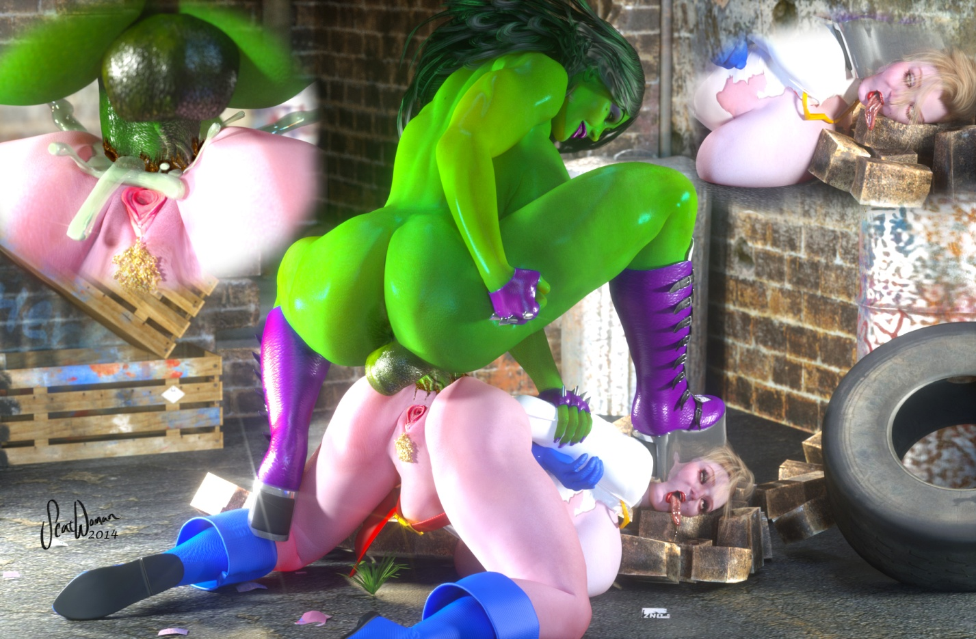

She-Hulk growled as she then began mercilessly hammering the pinned, curvaceous blonde’s bountiful butt with her raging-hard mega-dick, churning her shit into buttery paste. She-Hulk roared as she pummeled and pounded and SMASHED the cocky Kryptonian’s fudge factory, spilling its contents over the sides of her bruised and abused asshole. She could feel the green giant’s cock pushing against her insides and obscenely stretching out her belly on the other side. If she hadn’t still been mostly invulnerable despite the gamma/kryptonite radiation, the savage green she-male likely would have cracked her in two!

This was the first time Power Girl ever felt helpless, like the *bottom*. As She-Hulk savaged her creamy fat ass, Karen gave surrendered herself to the experience and found it kind of freeing… to give in, to be powerless, to be taken and just hang on for the ride.

Each powerful two-foot plunge of emerald she-meat took a bit more of Power Girl’s pride, eroding her arrogance and sending her spiraling deeper and deeper into a fugue of submissive bliss. An orgasm was building in her that came from a deep, dark place she’d never known existed in her... an orgasm that would obliterate all others that had cum before…

When She-Hulk plowed her power-prick all the way into Power Girl’s bowels and ground her pelvis against the blonde’s bubble butt, Power Girl knew the green giant was going to blow. As She-Hulk roared and exploded, emptying her massive green balls into Power Girl’s guts, the trapped Kryptonian woman lost her SHIT. She howled and screamed and thrashed and kicked her way through the absolute most INTENSE orgasm she’d ever experienced in her VERY experienced sex life. It was incredible, life-changing. And it was just her first of many that day.

For as soon as She-Hulk’s cock finished twitching and shooting its last, thick rope of gamma-goo into Power Girl’s butt, the green giantess began humping AGAIN. Slowly at first, but building up speed quickly, she was soon back to full force and tempo, ravaging Power Girl’s rectum as if she *hadn’t* just dropped a pint of super-powered spunk into the blonde’s bowels!

Power Girl couldn’t believe the stamina this great green fuckmachine had. Over the next several hours, She-Hulk pounded her ass incessantly, never softening, never flagging, never slowing down or easing up. Power Girl lost count of how many times She-Hulk had bust her huge nuts inside her, but her guts were positively flooded with the hot, sticky light-green spooge. It had overflowed and ran all down her legs and pooled into a large puddle under her.

Power Girl had lost all conscious awareness and had gone totally slack by the time She-Hulk dumped her last massive load inside her. Karen’s eyes were rolled back in her head and she was drooling, in an altered state of complete subjection. She had cum so many times and so hard that she had blacked out once or twice, only to wake up to She-Hulk’s continuing anal annihilation.

She-Hulk finally pulled out of Power Girl’s great, gaping asshole sometime that evening. Power Girl had no idea how long she’d been ass-raped – she had no awareness of time anymore. She was completely limp and offered no resistance at all as She-Hulk yanked her up by the hair and shoved her finally-softening, shit-covered green prick down the blonde’s throat, cleansing her cock in Karen’s mouth.

“Mmm,” She-Hulk moaned in satiation, “I NEEDED that.”

She looked down at Power Girl.

“Looks like YOU did, too, Power Slut,” She-Hulk grinned.
It was true. Power Girl had discovered a new side of herself, a side she never would have let herself explore. Now she had to admit she craved being dominated in this way, to be treated like a complete whore, to be taken, dominated, RAPED. Of course nobody else can know - this will have to be her dirty little secret hidden away in a bizarre alternate universe only she knows about. Besides, nobody else could physically overpower her the way this giant green bitch had… and the SAVAGERY… it was surreal, incredible… and absolute ecstasy.

Power Girl didn’t even flinch as She-Hulk drained her bladder down her throat.

“Ahhhhh…” She-Hulk sighed appreciatively, “I’ve been holding that piss ALL day…”

As she drained her full, bursting bladder down the blonde superheroine’s throat, She-Hulk picked up the Mega Rod Power Girl had dropped.

“I’m guessing this is the device you used to drop in on us, isn’t it?” She-Hulk inquired.

When Power Girl didn’t answer (too dazed and preoccupied with the feeling of She-Hulk’s hot piss draining into her gut), She-Hulk was forced to get the defeated superhero’s attention.

“I said: ISN’T IT?!!” She-Hulk demanded as she twitched her dick down the busty blonde’s throat making her whole body jerk and jiggling her fat tits. This caused a powerful jet of piss to spray from her giant green cock and hit Power Girl in the belly like a gut-punch.

Power Girl’s heavily lidded eyes shot open and she looked up at She-Hulk, locking eyes with her. She-Hulk enjoyed the expression of complete submission and surrender that she saw in the formerly arrogant blonde bitch’s eyes. Gone was the attitude, the overconfidence, the condescension. It their place was pure and simple subjugation.

Power Girl nodded, indicating She-Hulk’s guess about the Mega Rod was, in fact, correct. And she kept on swallowing the green woman’s hot, rancid piss as she stared up at her conqueror with cowed awe and fear.

She-Hulk smiled in satisfaction and examined the Mega Rod.

“Hmm, let me see… I bet *this* is the on switch…”

And, sure enough, a Boom Tube opened back to Metropolis, now street-level and daytime.

“Well, well, well,” She-Hulk sang as she squeezed off the last few potent jets of concentrated piss down Power Girl’s gullet and extricated her massive member from the blonde bimbo’s throat, “looks like you’re going home, Dorothy!”

With that, she tossed the used and abused Kryptonian through the Boom Tube unceremoniously. Power Girl tumbled through the tunnel, catching sight of She-Hulk waving the Mega Rod and calling after her:

“I’ll hold onto this for you so I can visit you REAL soon, Powerbitch!”

Power Girl tumbled across the pavement making the cars on the busy street screech to a halt. A crowd gathered around to gawk at the stripped, beaten and thoroughly used superhero. The onlookers pointed and laughed in disbelief.

A woman’s voice was heard over the din and she pushed her way through the mob and waved at them to disperse.

“Get the Hell out of here!” Lois Lane yelled, “what the Hell’s wrong with you people, can’t you see Power Girl’s been defeated and raped?! She needs help, not an audience!”

As Power Girl lay in the middle of the street, coughing up piss and leaking a steady flow of light-green gamma-spunk into a puddle by her ass, she looked up and thanked Lois.

“Th-thank you…” she managed to sputter.

“Who DID this to you?!” Lois helped Power Girl to her feet. But Power Girl was already feeling stronger, having returned to the full yellow sun of Earth Prime and having no kryptonite radiation bombarding her.

“Nobody, it’s-“ Power Girl began to lie, but the “pop” of a flashbulb interrupted her.

“Smile, Power Girl!”

She spun around to see Jimmy Olsen, with a large, pervy grin on his face, taking pictures of her half-naked, soiled, bodacious body.
0.8 seconds later, Jimmy was flat on his back in a nearby alley having She-Hulk’s jizz being forcefully sharted into his brimming mouth as Power Girl sat on his face and pinned him to the dirty alley ground. And his little dick was rock-hard and leaking pre-cum. And, this time, Lois was the one snapping the pictures.

Power Girl focused on emptying every last drop of She-Hulk’s deeply-injected spunk into the voyeuristic pervert’s mouth, making him swallow it all down. As she did so, she began to scheme and plot her revenge against that giant green bitch… but despite her wounded pride, her thoughts kept drifting to fantasies of her next likely abuse than exacting revenge. Karen had to admit… she was in love!

“Ho, Power Girl!” came a voice from above. It was Wonder Woman! She descended softly and landed beside Power Girl. She took in the situation.

“Putting the male in his place, I see,” Wonder Woman nodded approvingly.

Power Girl smiled. She often thought Wonder Woman was a bit too uptight and straight-laced, but she could appreciate her woman-dominated world view.

“Wonder Woman?!” Lois sputtered, staring up at the statuesque Amazon in awe.

Wonder Woman turned to look at her, “oh, yes, you’re that reporter that dates Clark Kent, aren’t you?”

“Uh… yeah?” Lois was confused, “You know Clark?”

Without batting an eye, Wonder Woman grabbed Lois by the hair and forced her to her knees against the wall. With the practiced expertise of a lifetime of such acts, she had pulled aside her star-spangled panties and was shitting down Lois’ throat! Wonder Woman wasn’t the jealous type, but she had to admit Clark’s constant pining about his unrequited love for Lois was incredibly annoying, especially now that she and Superman were an item.

As if using a human toilet was the most natural thing in the world, Wonder Woman continued, “When you are done, you must come to Themyscira. I have Supergirl there. She’s been training with Wonder Girl, but I think she could use some personal instruction from the BOTH of us.”

Power Girl grinned broadly as she shat a huge, thick dollop into Jimmy’s mouth forcefully, “Bitch, I like the way you think!”

To Be Continued!

(NOTE: This story branches here – back into Chapter 5 of “Supergirl’s Cumming Of Age” and it continues this series with the next battle between She-Hulk and Power Girl in Chapter 2 of “She-Hulk vs. Power Girl”)

-Scatwoman

